
Sreenidhi Institute of Science and Technology
Regulations:
A12
(An Autonomous Institution)
Code No: 3B721 Date:25-Nov-16(FN)
B. TECH. IV-Year I-Semester Examinations, Nov/Dec 2016 (Regular/Supple.)
PRINCIPLE OF FINITE ELEMENT METHOD (ME)

Time: 3 Hours Max. Marks: 70

Note: No additional answer sheets will be provided.

Part - A
Max.Marks:20

Answer all QUESTIONS. EACH QUESTION CARRIES 2 MARKS.

- What is the relationship between strain and strain displacement matrix. Derive it
- Define local, global and natural co-ordinates
- Mention the e-matrix for plane stress condition
- Sketch the geometry of isoparametric element and describe its assumptions and restrictions
- Mention conductance matrix for axial element
- Describe convergence criteria with the help of a neat sketch
- Define potential energy approach
- Mention the state of stress for axisymmetric state
- What are the types of error in FEM?
- Mention Hermite shape function for beam element
Part – B
Max.Marks:50

ANSWER ANY FIVE QUESTIONS. EACH QUESTION CARRIES 10 MARKS.
Note:- All sub-sections of a question must be answered at one place only

- The stepped bar shown in the figure is subjected to an increase in temperature , ΔT = 80 ͦC. Determine the displacements, element stresses and support reactions.
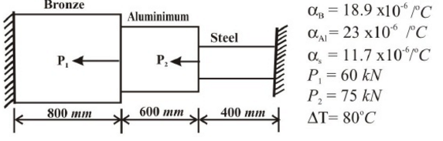
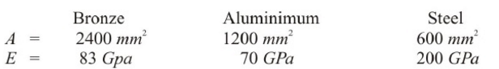

- Derive the transformation matrix for a plane truss element.
- Find the stresses in the plate shown in the figure using two rectangular plate elements. Take E = 200 GPa, = 0.3 and t = 10 mm . One end is fixed.
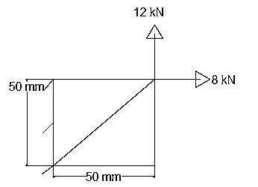
- From the fundamentals , derive the values of weighting function and location points when n = 2.
- A composite wall consists of three materials as shown in the figure. The outer temperature is T₀ = 20⁰C. Convection heat transfer takes place on the inner surface of the wall with T∞=800⁰C and h = 25 W/m² ⁰C. Determine the temperature distribution in the wall
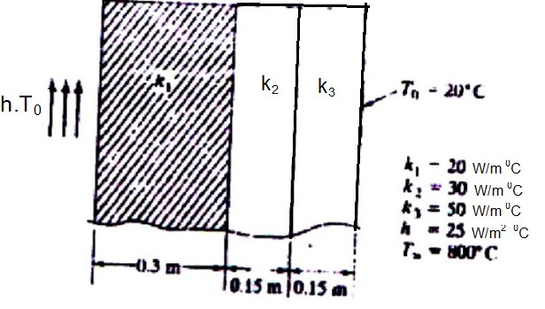
6. Find the natural frequencies of longitudinal vibration of the stepped bar shown . A = 1.5 e -3 m ²
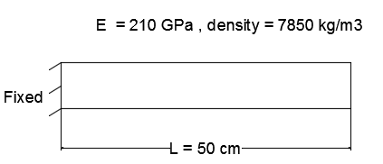
7. Derive K matrix for beam element
8. Derive shape function for two dimensional steady state heat conduction by triangular
element
-- 00 -- 00 --

